EXPERIMENT NO. 1
Property Buying & Rental Process using Zoho Creator (SaaS)

Aim
To develop a cloud-based Property Buying & Rental Process application using Zoho Creator for managing property purchase and rental details.

Objective
• Create a property management form.
• Store customer and property details.
• Generate reports for submitted records.
• Display alerts based on Buy/Rent selection using Deluge scripting.

Software Requirements
• Zoho Creator
• Google Chrome
• Internet Connection
• Deluge Script

Theory
Zoho Creator is a low-code cloud platform that enables users to build SaaS applications with minimal coding. In this experiment, a Property Buying & Rental Process application was created to manage property information. The application collects customer details, property information, budget range, and contact details. A Deluge script displays an alert message depending on whether the customer selects Buy or Rent.

Procedure
1. Login to Zoho Creator.
2. Create a new application named Property Buying & Rental Process.
3. Design the form with fields such as Customer Name, Buy/Rent, Property Type, Rental Agreement, Area, Budget Range, Place, Property Value, Mobile Number and Email.
4. Write a Deluge script using an if-else condition to display alerts for Buy and Rent.
5. Save the workflow.
6. Enter sample property records.
7. Create a report to display all submitted records.
8. Open individual records to verify the stored data.

Algorithm
Step 1: Start
Step 2: Open the Property Buying & Rental Process form.
Step 3: Enter customer and property details.
Step 4: Check Buy/Rent selection.
Step 5: If Buy is selected, display 'Property Purchase Selected'.
Step 6: Else display 'Property Rental Selected'.
Step 7: Submit the form.
Step 8: Store the record and display it in the report.
Step 9: Stop.

Deluge Script Used
if(input.Buy_Rent == "Buy")
{
alert "Property Purchase Selected";
}
else
{
alert "Property Rental Selected";
}

Observation
• The application accepted all customer details successfully.
• Buy/Rent selection triggered the appropriate alert message.
• Property details were stored correctly.
• Reports displayed all submitted records.
• Individual records showed complete information.
• The cloud application functioned correctly without errors.

Result
The Property Buying & Rental Process application was successfully developed in Zoho Creator. The Deluge script worked correctly, records were stored successfully, and reports displayed the data accurately.

Conclusion
The experiment demonstrated the creation of a SaaS-based property management application using Zoho Creator with Deluge scripting for simple decision making.

Output
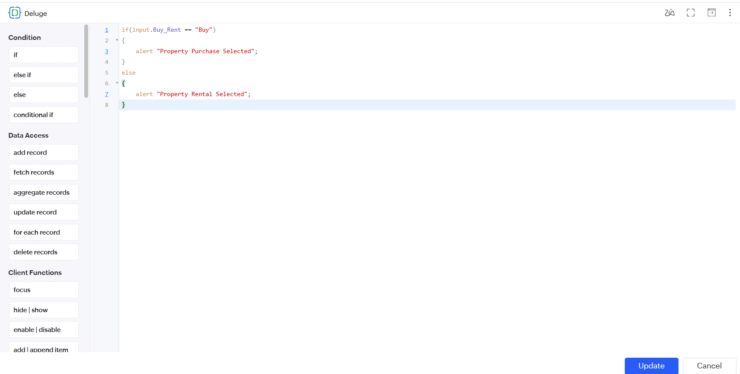
Figure 1: Deluge Script
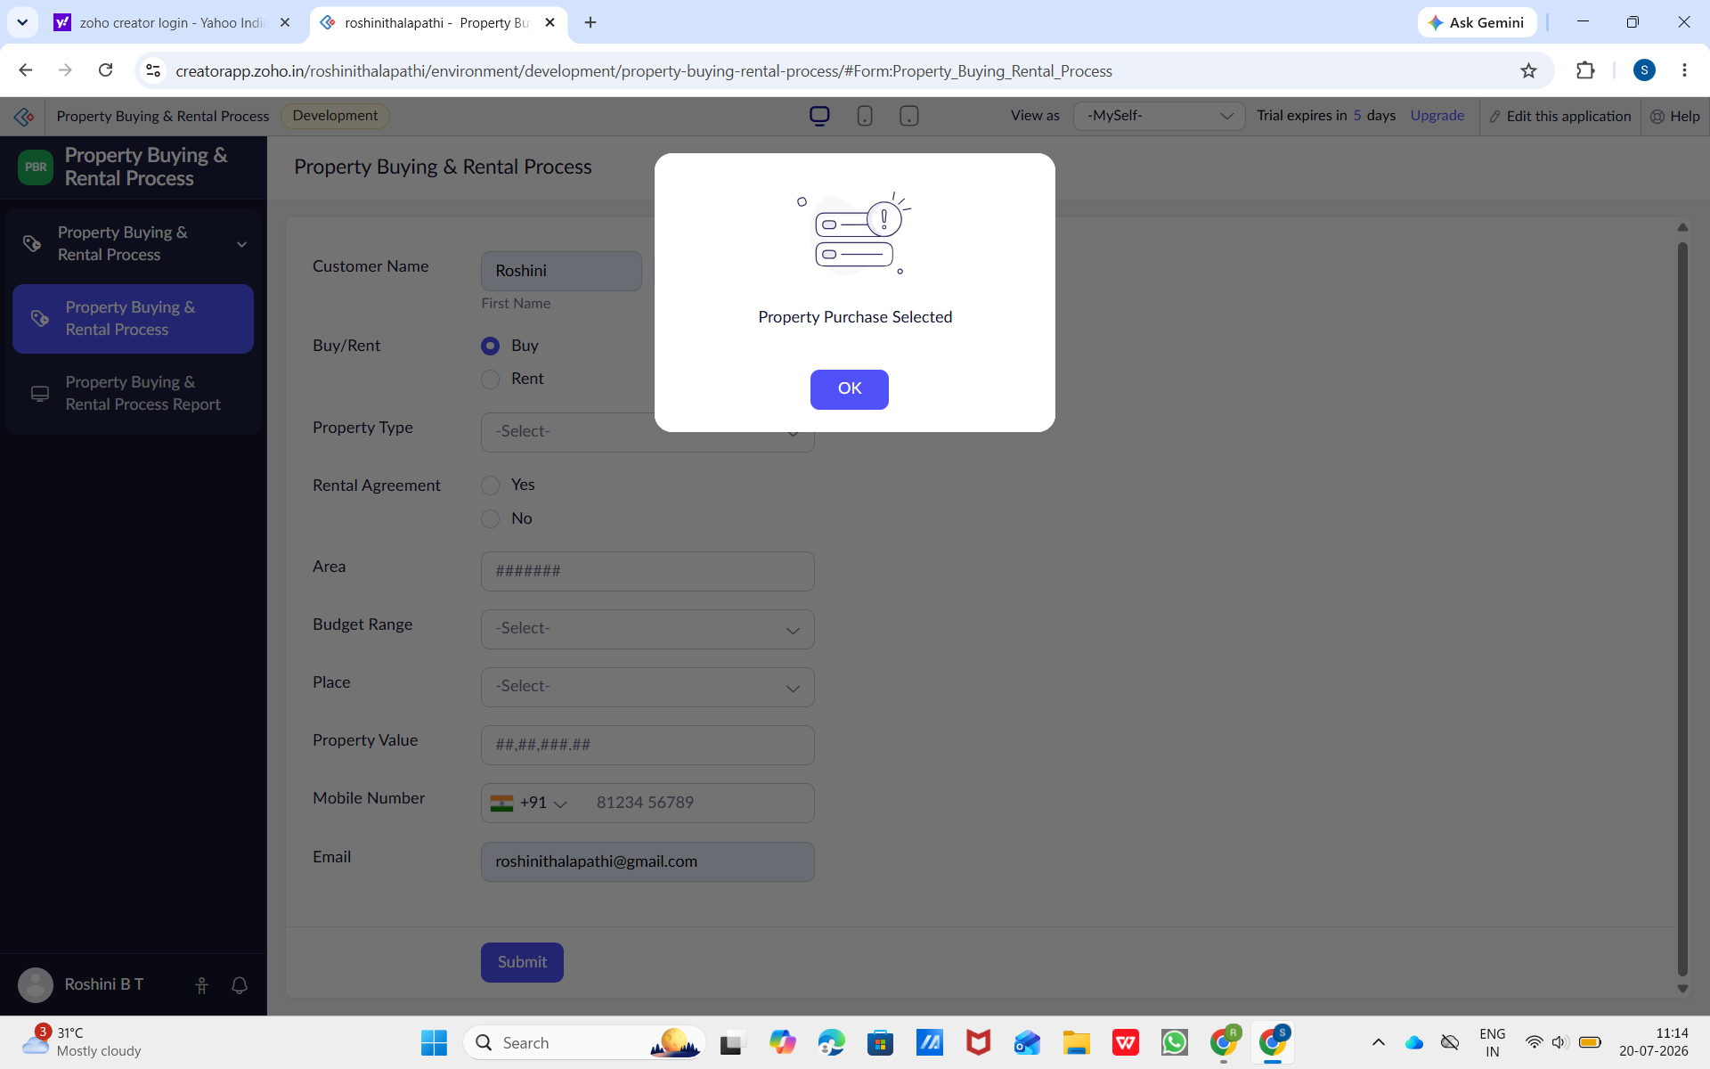
Figure 2: Alert Message
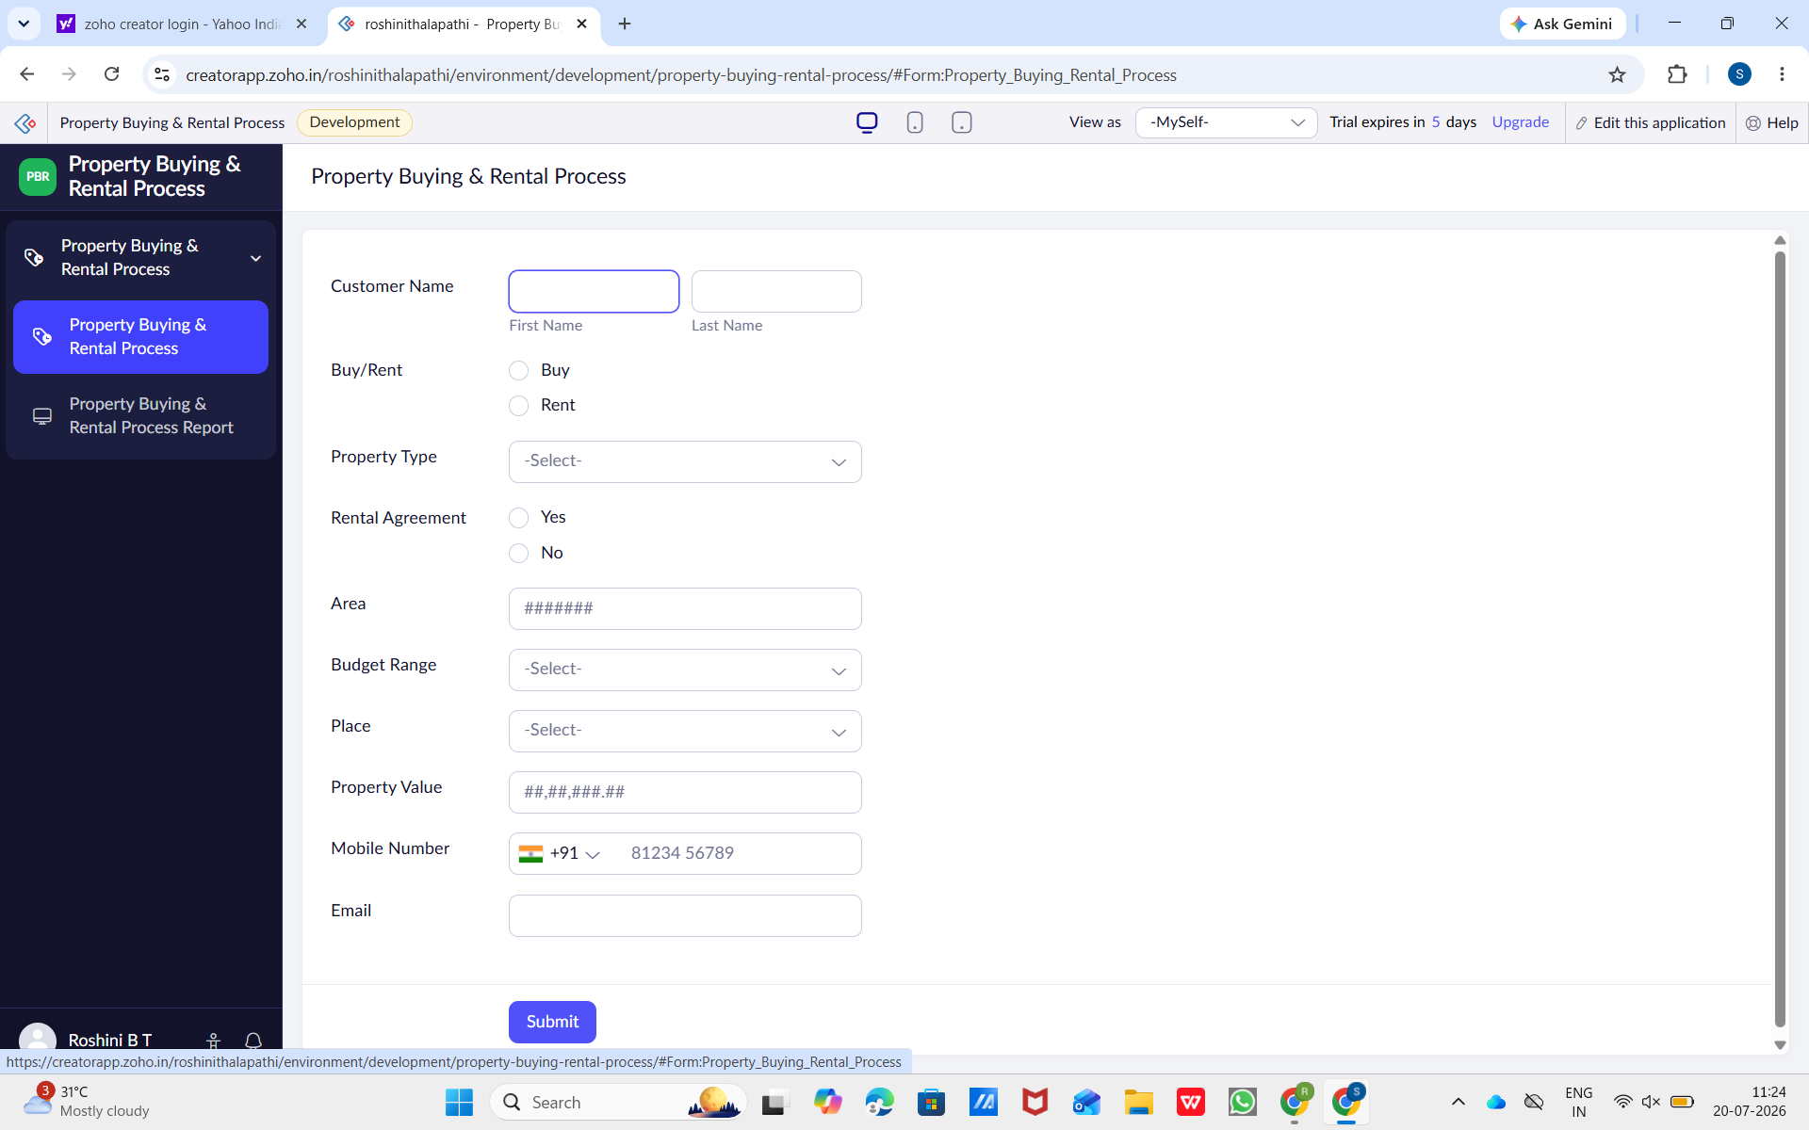
Figure 3: Property Entry Form
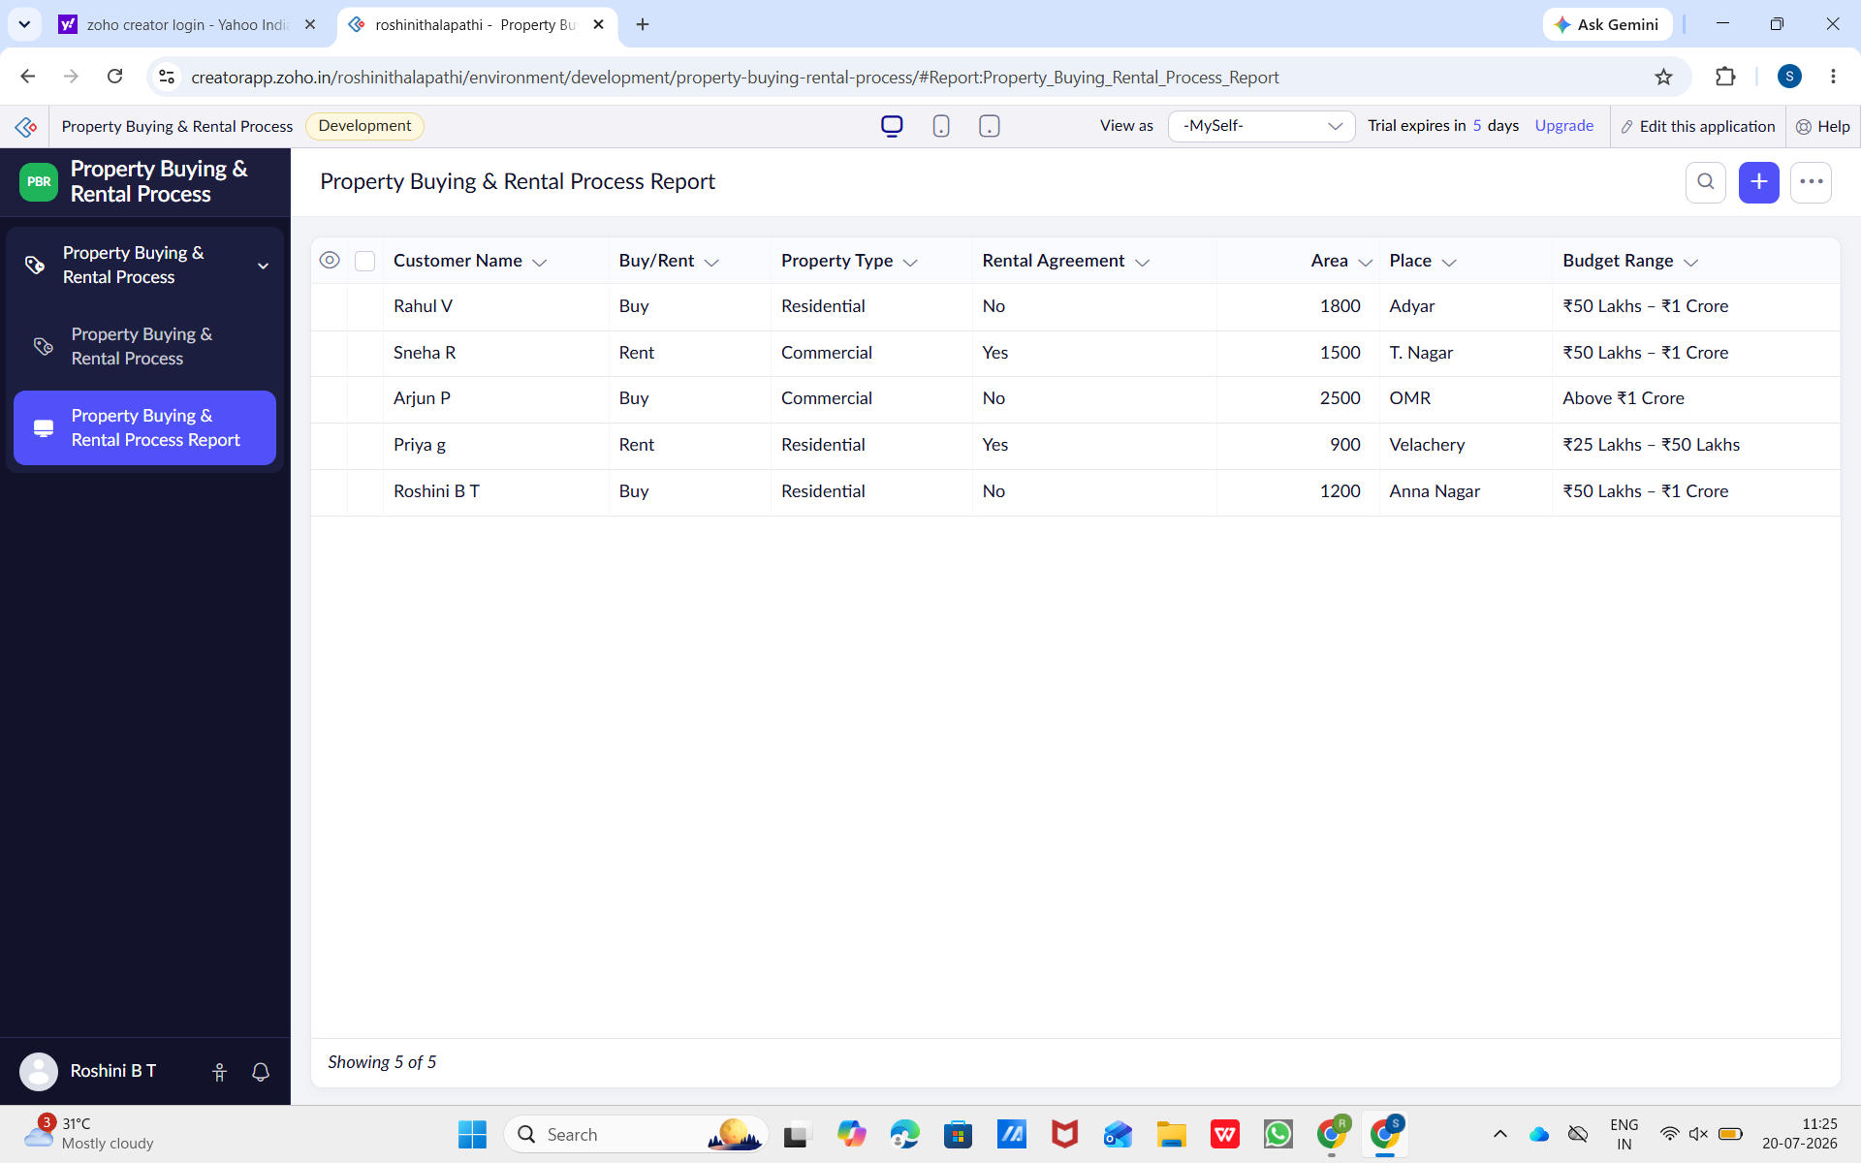
Figure 4: Property Report
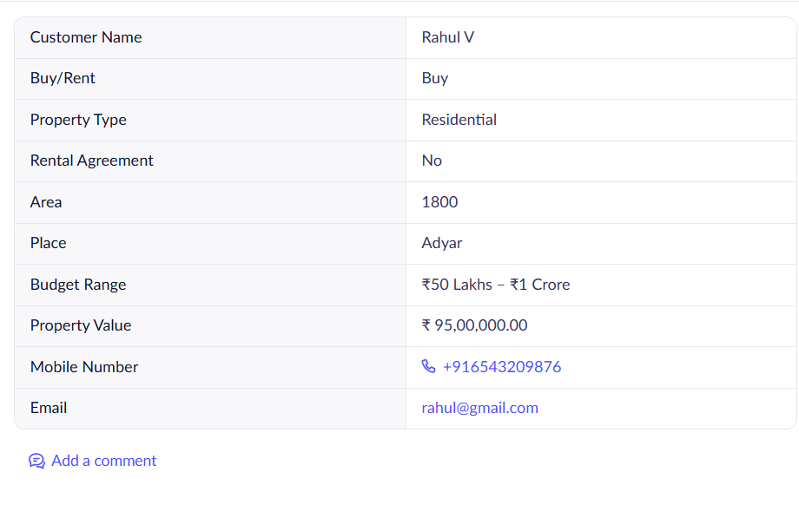
Figure 5: Individual Record View

